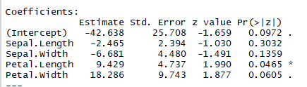

1. The logistic regression function is ln(p/1-p) = -42.638 – 2.465xSepal.Length – 6.681xSepal.Width + 9.429xPetal.Length + 18.286xPetal.Width.
2. -42.638 means the interception on ln(p/1-p) would be -42.638. -2.465 means for every increase on Sepal.Length, there would be a decrease of 2.465 on ln(p/1-p). -6.681 means for every increase on Sepal.Width, there would be a decrease of 6.681 on ln(p/1-p). 9.429 means for every increase on Petal.Length, there would be an increase of 9.429 on ln(p/1-p). 18.286 means for every increase on Petal.Width, there would be an increase of 18.286 on ln(p/1-p).
3. Odds(Petal.Length) = exp(9.429) = 12,444.076
4. This implies that the odds of being virginica are multiplied 12,444.076 for every millimeter of the petal length
5. No. Because larger of sepal and less probability to be the virginica iris.
6. Sepal.Length =0, Sepal.Width=0, Petal.Length=0, Petal.Width=0

Odd = exp(0)=1

Sepal.Length =0.1, Sepal.Width=0, Petal.Length=0, Petal.Width=0

Odd = exp(0.1x-2.465) = 0.782

0.782<1, the odds decreased